Supporting Information
3. Material and Methods
2S. Response surface methodology
The response surface method was used to investigate the effect of interactions between three independent variables (pH, temperature, and time) based on Design Expert® (Version 11.1.2.0, Stat-Ease Inc. USA) software. The data was screened by central composition design (CCD). Evaluation of related models was performed through analysis of variance (ANOVA). Standard deviation analyses of enzyme activity are shown in Table 2. Finally, optimal values were achieved for each variable.
4. Result
3S. Optimization of cultural conditions
3S1. Effect of different carbon and nitrogen sources
Culture condition optimization is necessary for the enhanced production of protease for industrial applications. Different sources of nitrogen and carbon were examined. According to the experiments, starch and sucrose were identified as the best sources of carbon (Fig. S1A). Also, almost all tested nitrogen sources had a good effect on protease production by DEM05 protease. (Fig. S2B).
Fig. S1
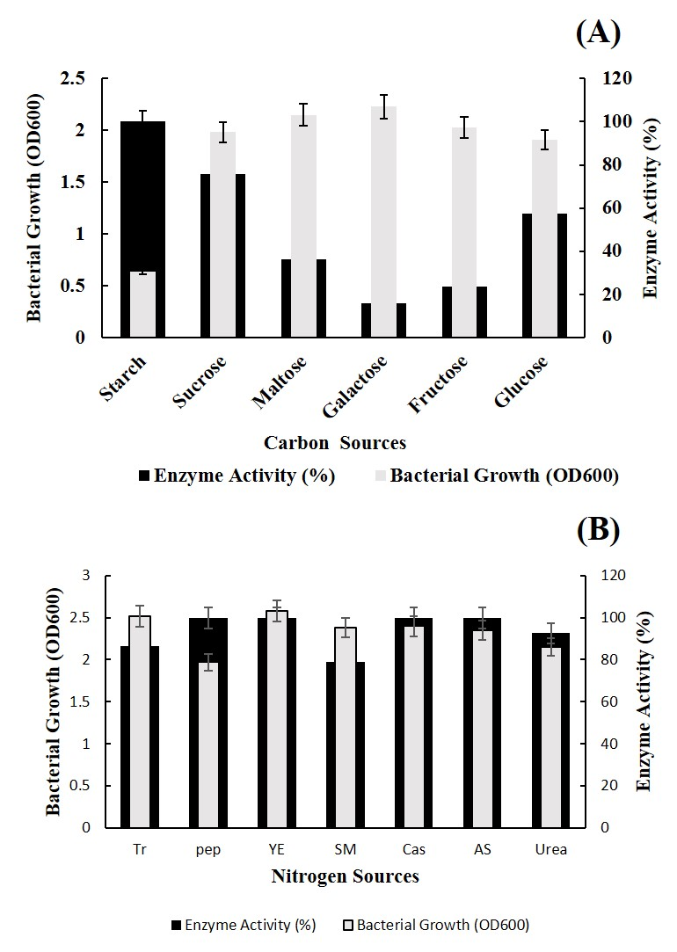

Fig. S1. Effect of carbon (A) and nitrogen (B) sources on the production of protease DMEM05. Data are representative of at least three independent experiments (the error bars indicate ±SD).

3S2. Optimization of Protease production by one- factor- at- a- time method
The incubation times were selected from 24 to 96 h, and the maximum bacterial growth and protease production were achieved at 72 h. The best bacterial growth and enzyme production were obtained at pH 7. Within the wide range of tested temperatures, the maximum biomass and enzyme production was observed at 37 ºC (Table S1).
3S3. Optimization of protease production by RSM
The results of CCD (Table S2) and ANOVA (Table S3) were shown. In this context, the chosen model is completely meaningful implying that all variables affect the enzyme activity. For “lack of fit”, the p-value is determining factor that a fit model and/or model is not reached by chance and error. Table S3 showed statistical data for enzyme activity response. The coefficient of determination (R²) is about 98 meaning that 98% of the achieved data is under anticipated values. Accordingly, the final equation in terms of coded factors for enzyme activity was obtained as below:
(Enzyme activity)² | =
+275.17
+15.37 | A
+10.62 | B
-27.18 | C
+43.52 | AB
-22.59 | AC
-16.67 | BC
-15.40 | A²
-87.08 | B²
+45.28 | C²

Where A, B, and C are the coded levels of time, pH, and temperature, respectively. B² has the utmost effect on protease activity. The interaction between time and pH on the activity of the enzyme was shown in Fig. S2A in which the augmentation of time is associated with increased enzyme activity and pH in this state is about 8-9. We concluded that under these conditions, pH increases to about 9, increasing the enzymatic activity and gradually decreasing the activity from 9 onwards. The interaction effect of time and temperature indicates that the maximum enzyme activity is obtained at lower temperatures and longer times (Fig. S2B). As shown in Fig. S3C, the maximum enzyme activity is caused at lower temperatures and pH between 8 and 9. Finally, the optimum point of 19.61 U/ml achieved from software is associated with a temperature of 37 °C, pH of 8.8, and time of 72 h for the optimum enzyme activity.
Fig. S2

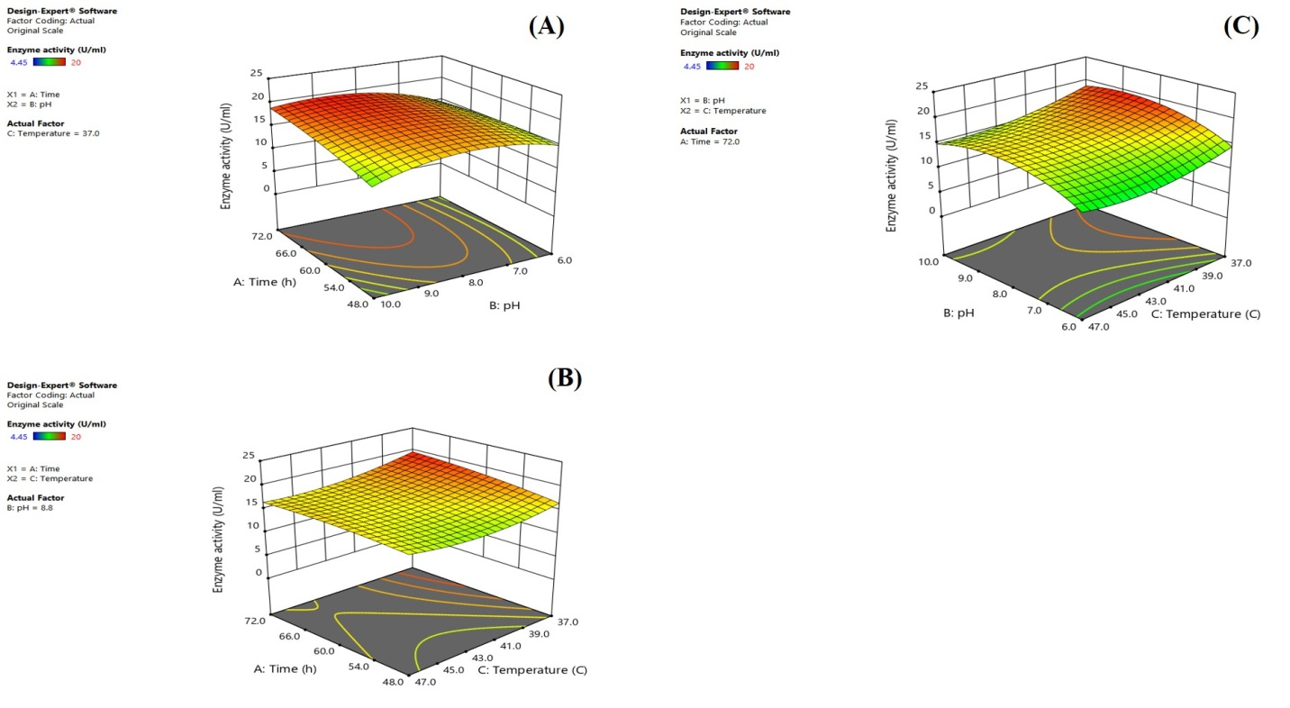

Fig. S2. Three-dimensional pot obtained from RSM with the interaction effect of different variables on the production of protease isolated from Bacillus sp. DEM05. Interaction between time and pH at 37 °C (A). Interaction between time and temperature at pH=8.8 (B). Interaction between pH and time at the time of 72 h (C).

Table S1. Effect of time, pH, and temperature on enzyme production.
Incubation time (h) pH Temperature (°C)
24 48 72 96 4 5 6 7 8 9 10 37 40 45 47 50 55 60
Relative activity (%)  ±SD | 58 85 100 38 38 31 89 100 70 85 20 100 85 82 80 65 24 19  0.3 0.2 0.2 0.6 0.5 0.6 0.4 0.3 0.7 0.5 0.9 0.4 0.6 0.3 0.2 0.5 0.7 0.2
Bacterial growth (OD₆₀₀)  ±SD | 1.2 1.5 2.3 0.7 0.3 0.4 1.2 1.4 0.8 1.0 0.3 1.5 1.6 1.1 0.8 0.6 0.2 0.3  0.2 0.3 0.2 0.1 0.1 0.2 0.3 0.2 0.1 0.3 0.2 0.3 0.2 0.2 0.1 0.2 0.1 0.1
Each value represents the means of three experiments and the error bar indicates ±SD.

Table S2. Results of Central Composite Design (CCD).
 |  | Factor 1 | Factor 2 | Factor 3 | Response
Std | Run | A: Time | B: pH | C: Temperature | Enzyme activity
 |  | (h) |  | (°C) | Uml⁻¹
8 | 1 | 72.0 | 10.0 | 47.0 | 15.49
20 | 2 | 60.0 | 8.0 | 42.0 | 16.19
3 | 3 | 48.0 | 10.0 | 37.0 | 13.87
12 | 4 | 60.0 | 11.4 | 42.0 | 5.35
4 | 5 | 72.0 | 10.0 | 37.0 | 18.85
18 | 6 | 60.0 | 8.0 | 42.0 | 16.79
6 | 7 | 72.0 | 6.0 | 47.0 | 12.3
7 | 8 | 48.0 | 10.0 | 47.0 | 12.75
16 | 9 | 60.0 | 8.0 | 42.0 | 16.79
14 | 10 | 60.0 | 8.0 | 50.4 | 18.3
17 | 11 | 60.0 | 8.0 | 42.0 | 16.92
1 | 12 | 48.0 | 6.0 | 37.0 | 14.53
2 | 13 | 72.0 | 6.0 | 37.0 | 14.31
19 | 14 | 60.0 | 8.0 | 42.0 | 16.12
11 | 15 | 60.0 | 4.6 | 42.0 | 4.45
15 | 16 | 60.0 | 8.0 | 42.0 | 16.75
9 | 17 | 39.8 | 8.0 | 42.0 | 14.28
5 | 18 | 48.0 | 6.0 | 47.0 | 15.9
13 | 19 | 60.0 | 8.0 | 33.6 | 21.5
10 | 20 | 80.2 | 8.0 | 42.0 | 15.81

Table S3. Data obtained from ANOVA for Quadratic model.
Source | Sum of Squares | df | Mean Square | F-value | p-value
Model | 1.899E+05 | 9 | 21099.45 | 80.36 | < 0.0001
A-Time | 3225.59 | 1 | 3225.59 | 12.29 | 0.0057
B-pH | 1540.34 | 1 | 1540.34 | 5.87 | 0.0359
C-Temperature | 10088.69 | 1 | 10088.69 | 38.43 | 0.0001
AB | 15154.36 | 1 | 15154.36 | 57.72 | < 0.0001
AC | 4083.51 | 1 | 4083.51 | 15.55 | 0.0028
BC | 2224.44 | 1 | 2224.44 | 8.47 | 0.0155
A² | 3418.63 | 1 | 3418.63 | 13.02 | 0.0048
B² | 1.093E+05 | 1 | 1.093E+05 | 416.19 | < 0.0001
C² | 29546.41 | 1 | 29546.41 | 112.54 | < 0.0001
Residual | 2625.49 | 10 | 262.55
Lack of Fit | 1977.60 | 5 | 395.52 | 3.05 | 0.1230
Pure Error | 647.89 | 5 | 129.58
Cor Total | 1.925E+05 | 19

