Supplementary Table 1. Microbiological and biochemical properties of Raoultella planticola
Property | Reactions
Gram stain | Negative
Morphology | Capsulated rod
Motility | Negative
Spore-forming | Negative
Color production | Negative
Gas production | Positive
Oxidase | Negative
Catalase | Positive
Citrase | Positive
Glucose | Positive
Lactose | Positive
Sucrose | Positive

Supplementary Table 2. Antimicrobial susceptibility of MDR isolates
Antimicrobial drug | S. aureus | B. cereus | K. pneumoniae | Enterobacter | E. coli | P. aeruginosa | Salmonella | Shigella
Benzylpenicillin | R | - | - | - | - | - | - | -
Oxacillin | R | - | - | - | - | - | - | -
Ampicillin | - | R | R | - | R | R | R | R
Amoxicillin/Clavulanic acid | - | - | R | R | - | R | R | -
Ticarcillin | - | - | R | R | - | R | - | -
Piperacillin/Tazobactam | - | - | R | R | R | R | - | -
Cefalotin | - | - | R | R | - | R | - | -
Cefoxitin | - | R | R | R | S | R | - | R
Ceftriaxone | - | - | - | - | R | - | S | -
Cefotaxime | - | R | R | R |  | R | - | R
Ceftazidime | - | - | R | R | R | R | S | S
Erythromycin | R | R | - | - | - | - | R | R
Clindamycin | R | R | - | - | - | - | - | -
Imipenem | - | - | R | R | - | R | S | S
Gentamicin | S | S | I | R | R | R | R | S
Amikacin | - | S | R | R | S | R | S | S
Tobramycin | S | S | R | R | R | R | - | S
Ciprofloxacin | - | - | R | R | R | R | S | R
Levofloxacin | S | S | - | - | R | - | S
Ofloxacin | - | R | R | R | - | R | S | R
Rifampicin | R | R | - | - | - | - | - | -
Vancomycin | S | S | - | - | - | - | - | -
Teicoplanin | S | S | - | - | - | - | - | -
Nalidixic Acid | - | - | R | R | - | R | - | -
Nitrofurantoin | - | S | R | R | S | R | R | R
Trimethoprim/sulfamethoxazole | S | S | R | R | S | R | R | R
Note/ S, Susceptible; I, Intermediate; R, Resistant.

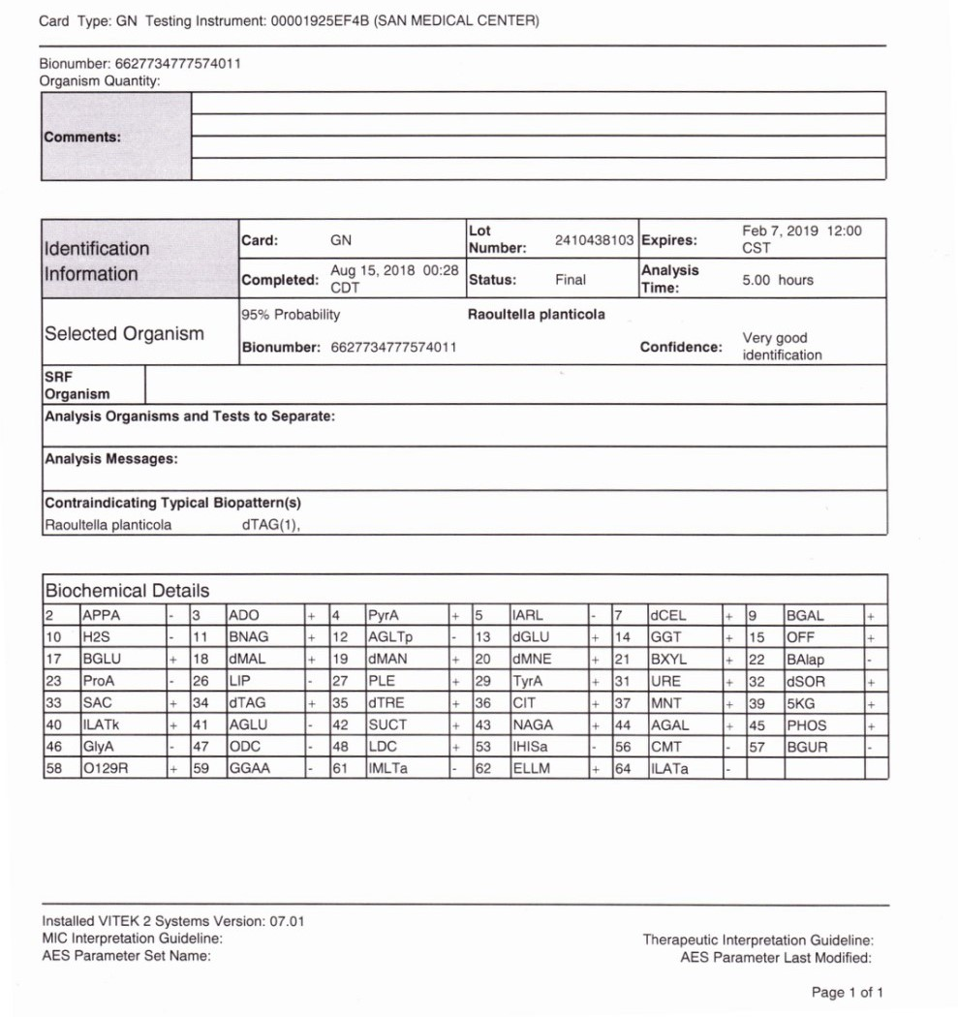
Supplementary report 1. VITEK-2 identification card report of R. planticola

