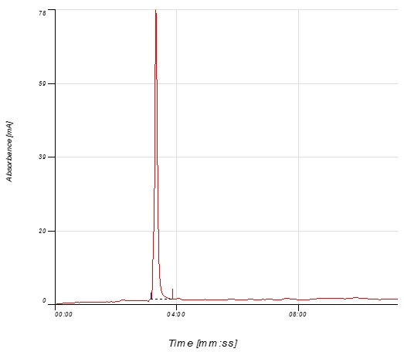
a

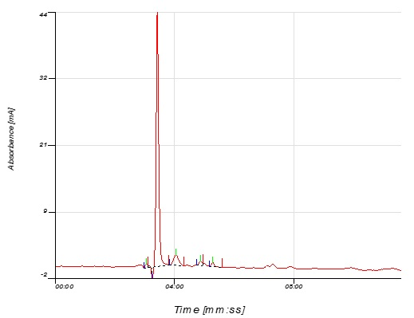
b

Fig. 1 chromatogram of oxalic acid standard (a) and oxalic acid detected in pathogen culture filtrate (b)

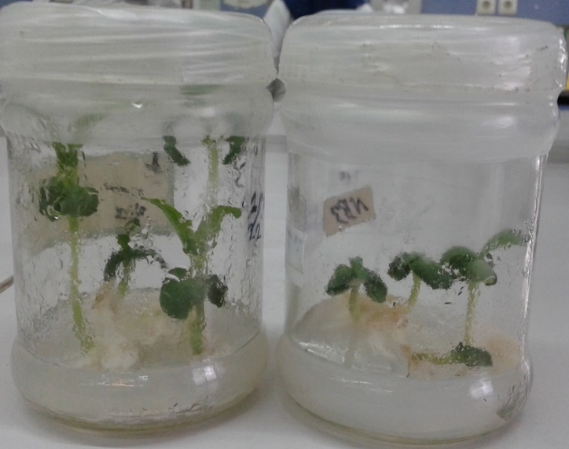
Fig. 2 different stages of plant growth
a b c d
e f g h
Fig. 3 Effect of stem treatment with culture filtrate of pathogen. The stems treated by Czapek-Dox medium as control in susceptible line (a), stems were treated with culture filtrate of pathogen in susceptible line at 24h (b), 48h (c), 72h (d). The stems treated by Czapek-Dox medium as control in partially resistant line (e), stems were treated with culture filtrate of pathogen in partially resistant line at 24h (f), 48h (g), 72h (h).

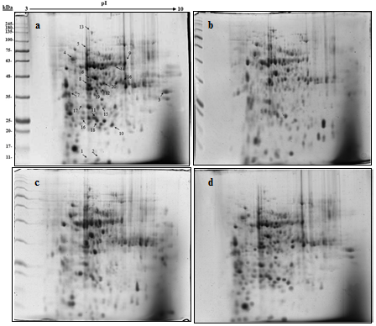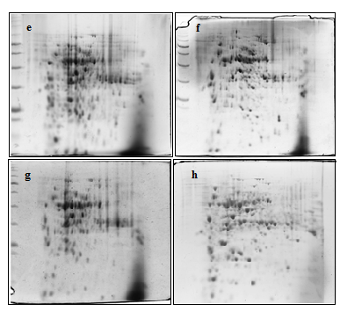

Fig. 4 The 2-DE was performed for both lines at 24, 48 and 72 h post treatment by using 7 cm IPG strips and 12% SDS-PAGE gels. Gels were stained with Coomassie Brilliant Blue R-250. (a) untreated partially resistant line, numbers and arrows shows significantly altered spots and their descriptions have been shown in Table 1; (b) partially resistant line at 24 h after treatment; (c) partially resistant line at 48 h after treatment; (d) partially resistant line at 72 h after treatment; (e) untreated susceptible line; (f) susceptible line at 24 h after treatment; (g) susceptible line at 48 h after treatment; (h) susceptible line at 72 h after treatment

