S1 Figure. The phenomenon of the Plodia interpunctella (Hübener) biting PE.
Figure S1. Plodia interpunctella (Hübener) biting PE
S2 Figure. The SEM image of ZJH-1.
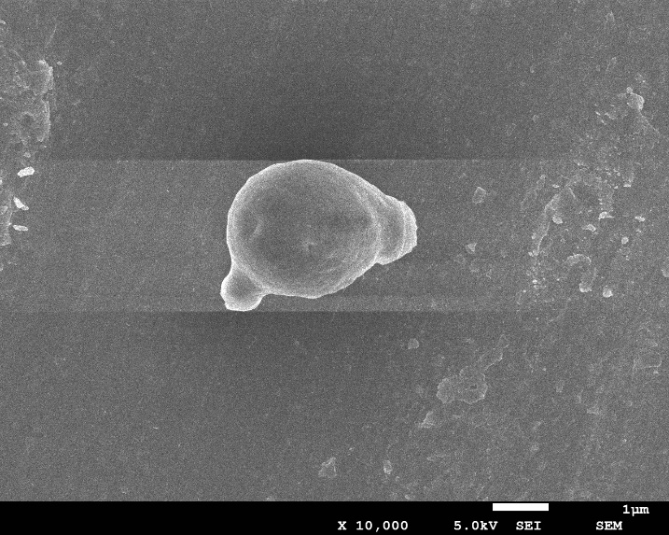
Figure S2. The SEM image of ZJH-1
S3 Figure. FT-IR spectra before and after Cr (VI) treatment by ZJH-1.
Figure S3. FT-IR spectra before and after Cr (VI) treatment by ZJH-1, Ⅰ: untreated Ⅱ: treated

S4 Figure. Effect of temperature on CChR activity.
Figure S4. Effect of temperature on CChR activity
S5 Figure. Effect of pH on CChR activity.
Figure S5. Effect of pH on CChR activity
S6 Figure. Effect of different metal ions on CChR activity.
Figure S6. Effect of different metal ions on CChR activity
S7 Figure. CChR's kinetic curve
Figure S7. CChR's kinetic curve
S1 Table. The groups corresponding to each characteristic peak.
Table S1. Comparison table of characteristic peaks of
each group before and after ZJH-1 treatment of Cr (VI)
Wavelength (cm⁻¹) | Tensile mode and belonging structure of telescopic vibration peak
3305 | -CH and -OH telescopic vibration zone
3280 | -OH, -NH and -CH telescopic vibration zone
2927 | -CH telescopic vibration zone includes -CH3 and CH2
2363 | -NH amide region
1740 | -C = O telescopic vibration zone-COOH
1647 | Amide I
1546 | Amide Ⅱ
1313 | -CN telescopic vibration zone
1035 | -CN telescopic vibration zone, P-O alkyl
S2 Table. Reduction of 50 mg·L⁻¹ Cr (VI) by various components of cells.
Table S2. Reduction of 50 mg·L⁻¹ Cr (VI) by various components of cells
Cell component | Cr (VI) reduction rate %
Resting cell | 56.7±0.09
Permeable cell | 60.4±0.11
A1 | 70.0±0.02
A2 | 10.0±0.02
A3 | 3.9±0.03
A1+NADH | 100±0.01
A2+NADH | 15.5±0.02
A3+NADH | 4.2±0.01

