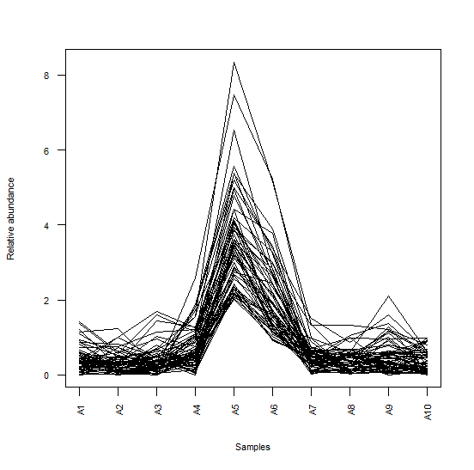 | 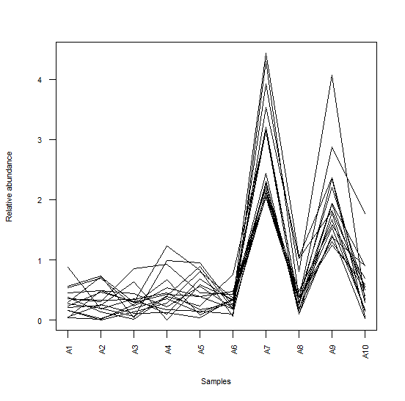
(a) | (b)
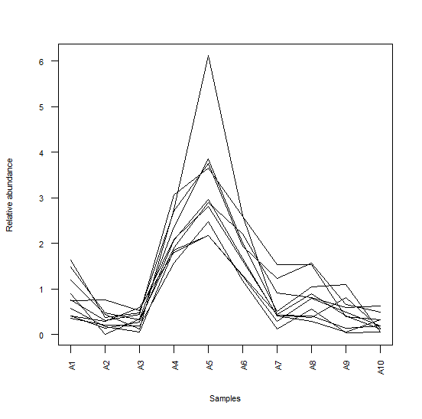 | 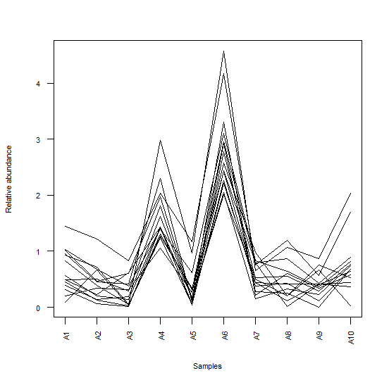
(c) | (d)
Sup2. Co-expression diagram for genes within each module. (a) Module5 (b) Module7 (c) Module8 (d) Module11. A1: salinity stress. A2: Maythorpe root. A3: Golden promise shoot. A4: Golden promise root cultivar. A5: Methyl jasmonate treatment. A6: treatment with MeJA and salinity stress. A7: Maythorpe cultivar-Shoot. A8: 3 hours (cultivar Morex). A9: cultivar Morex after 8 hours stress. A10: 27 hours (cultivar Morex).

