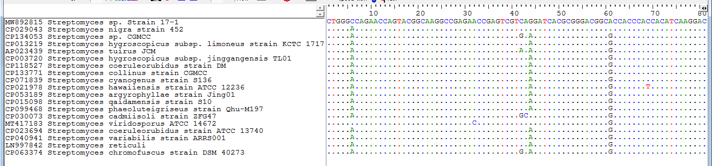
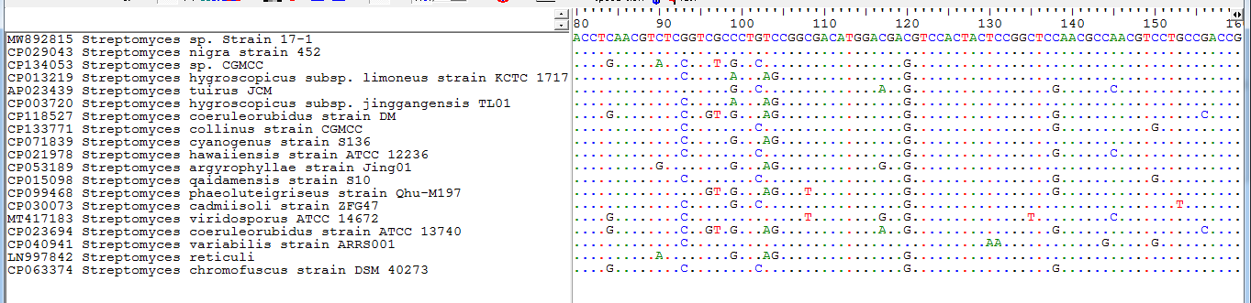
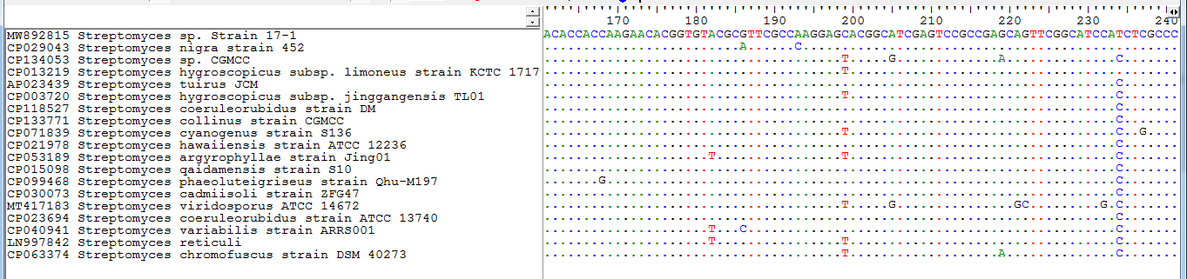
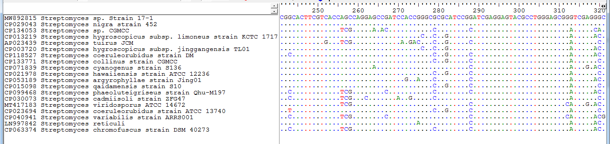
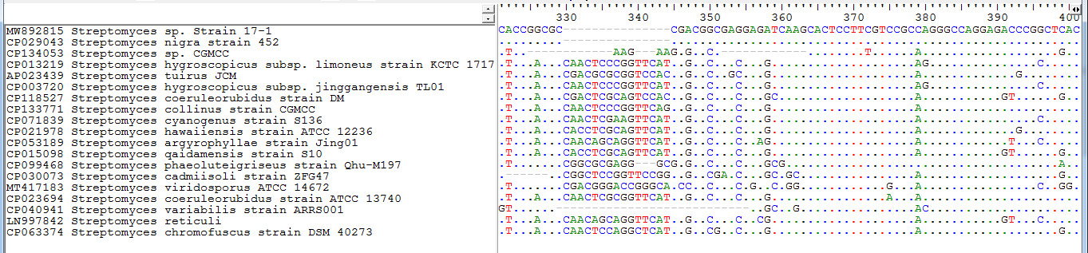
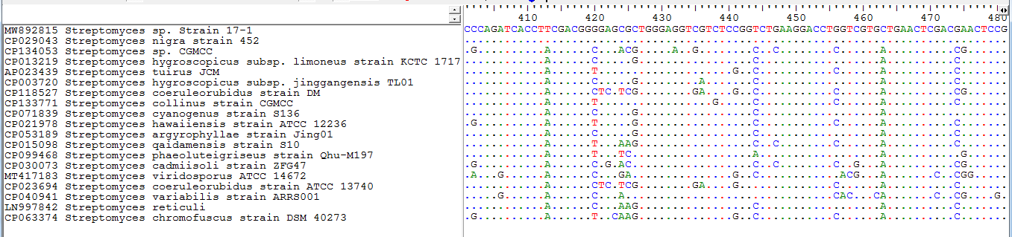

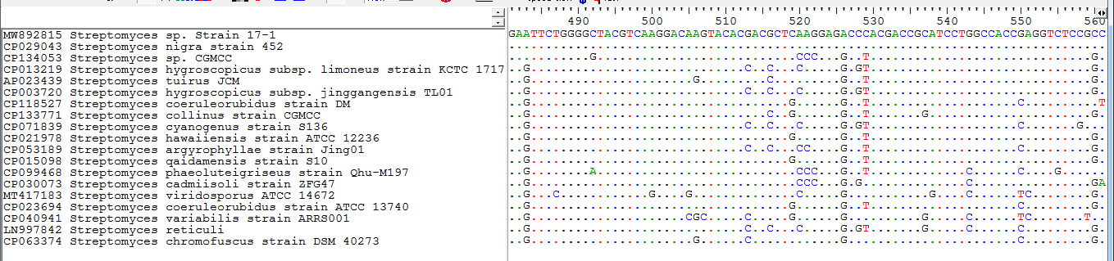
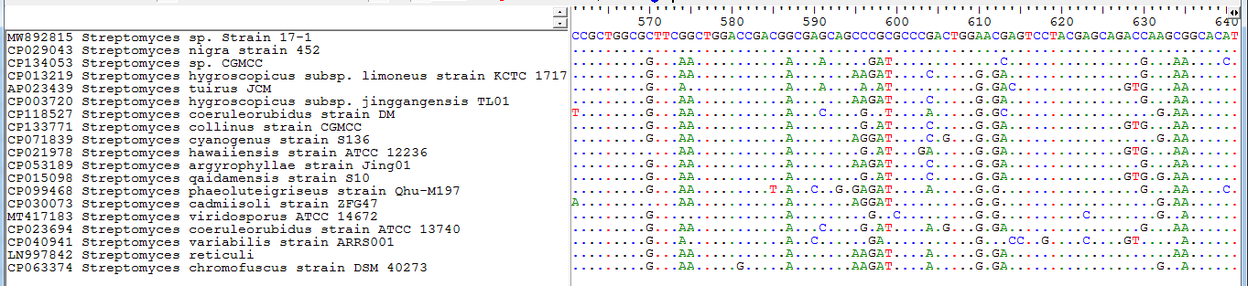
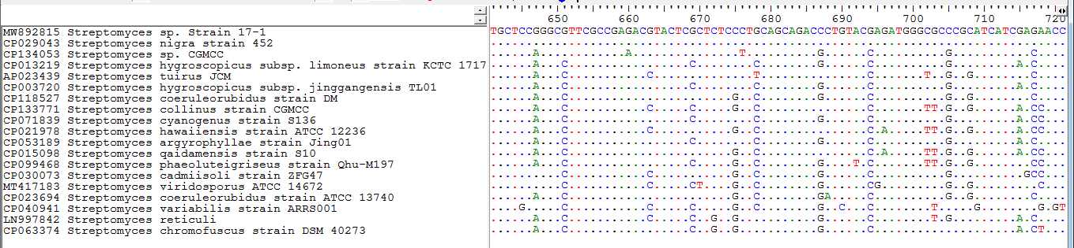
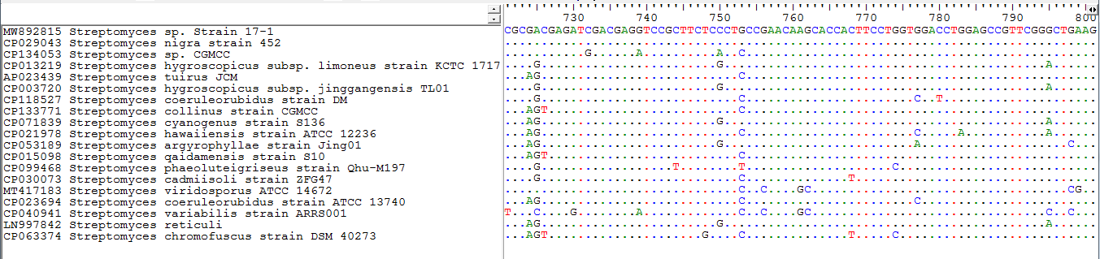
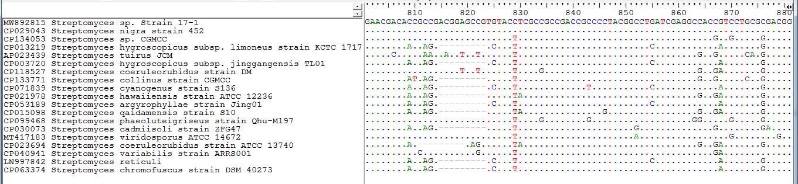
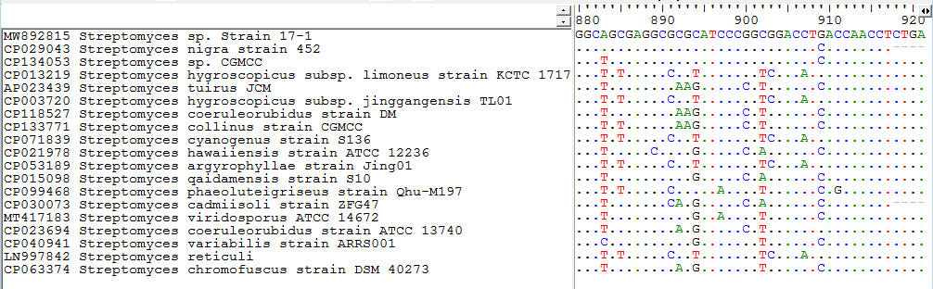

Fig S1. Multiple alignment result of uricase gene sequence from Streptomyces sp. strain 17-1 with the sequence of that gene from other close species according to NCBI nucleotide BLAST. According to the result, the closest sequence similarity is between the gene of Streptomyces sp. strain 17-1 and the gene of Streptomyces nigra strain 452.

