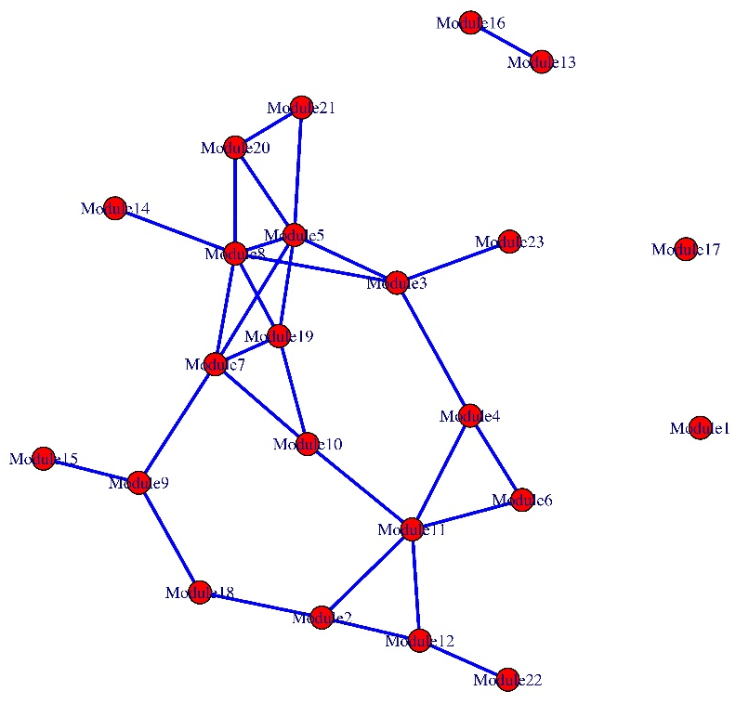
Sup1. Grouping of datasets genes in different expression modules.

