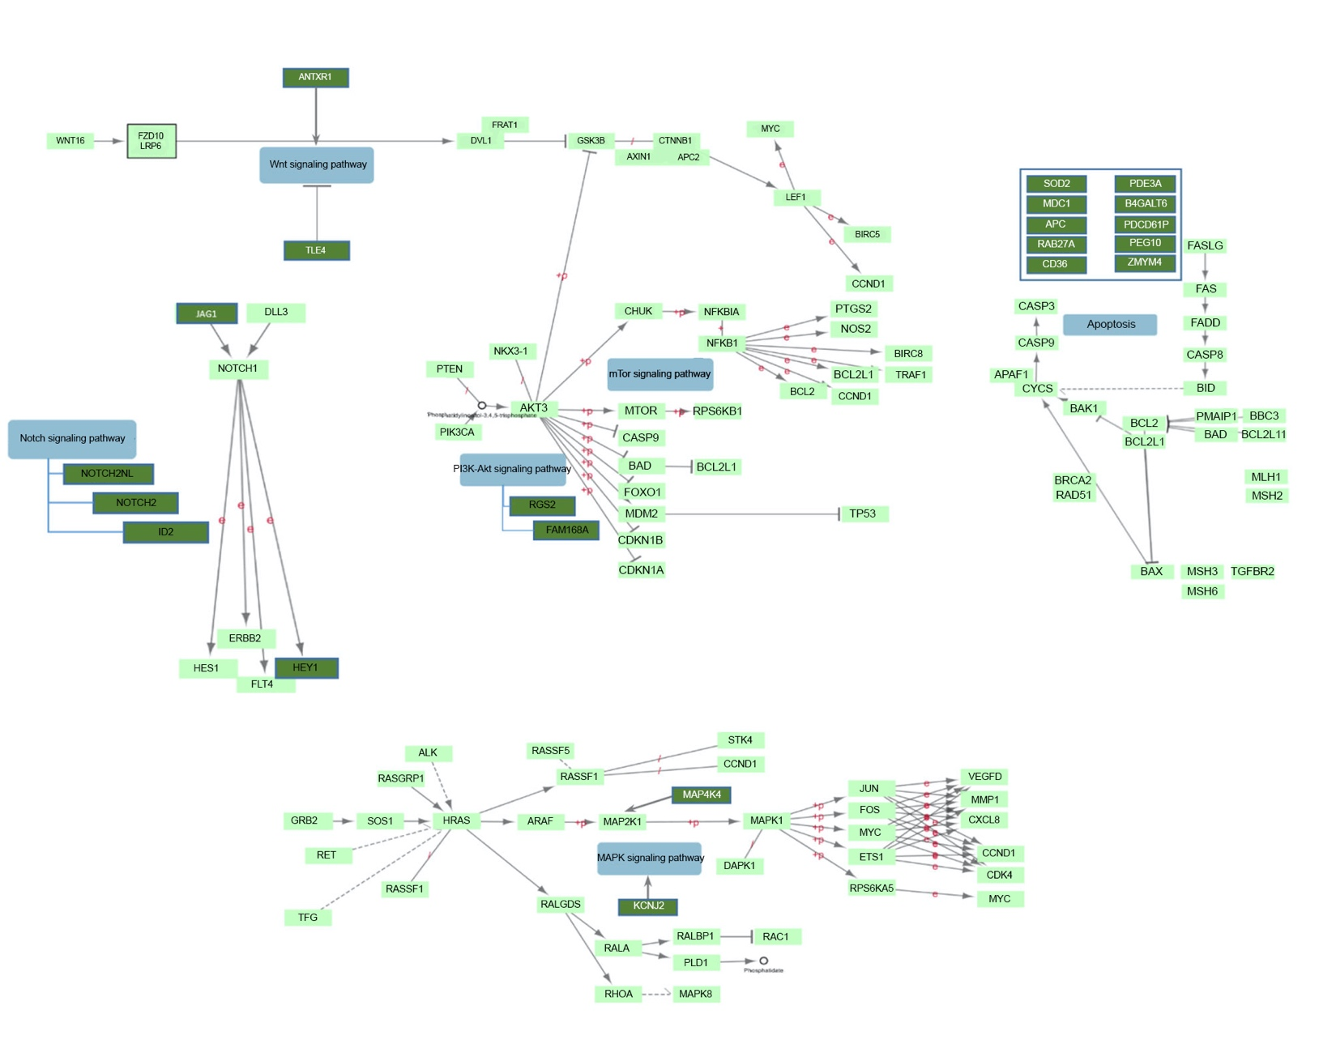

Figure S1. Involvement of some of up and/or down regulated DEGs in cancer related pathways. Genes are shown with solid green squares. The Roles of the other genes resistance or cancer induction are listed in table 1 .The cancer related pathway was extracted from KEGG database.

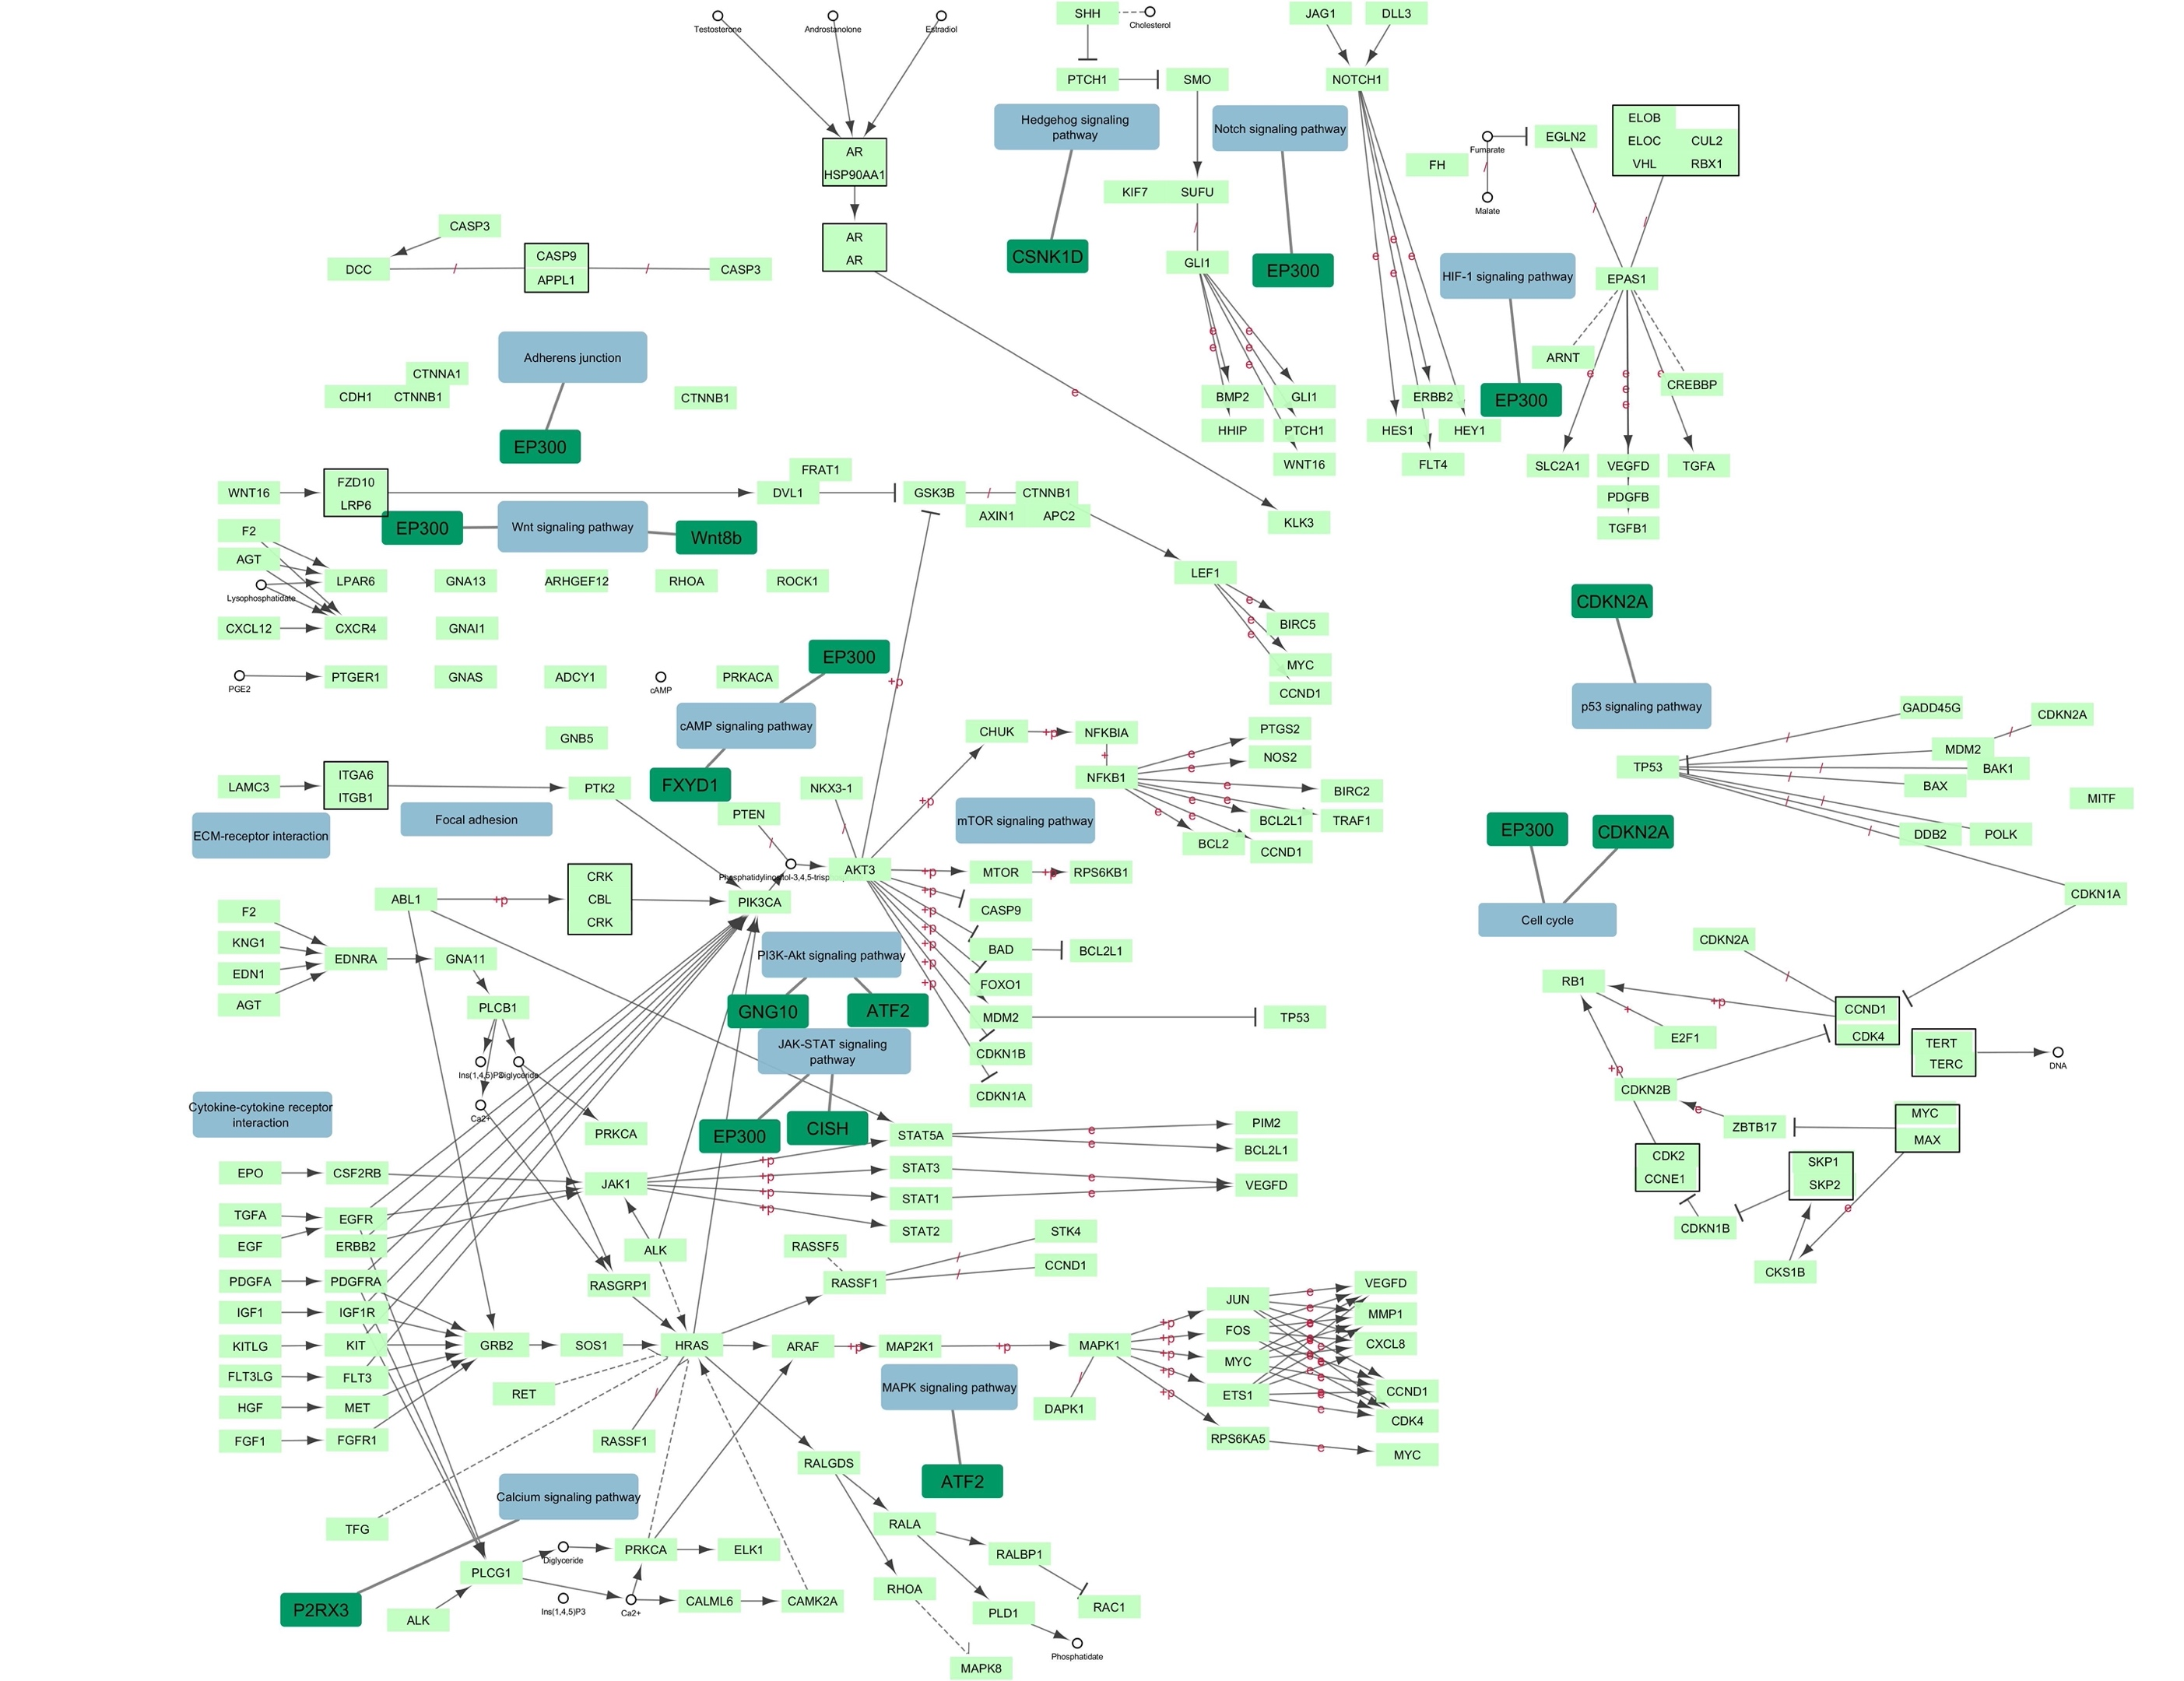

Figure S2. Cancer related KEGG pathways involvement of some of differentially co-expressed genes in resistant and sensitive ovarian cancer cell lines. Genes are presented with solid green squares.

