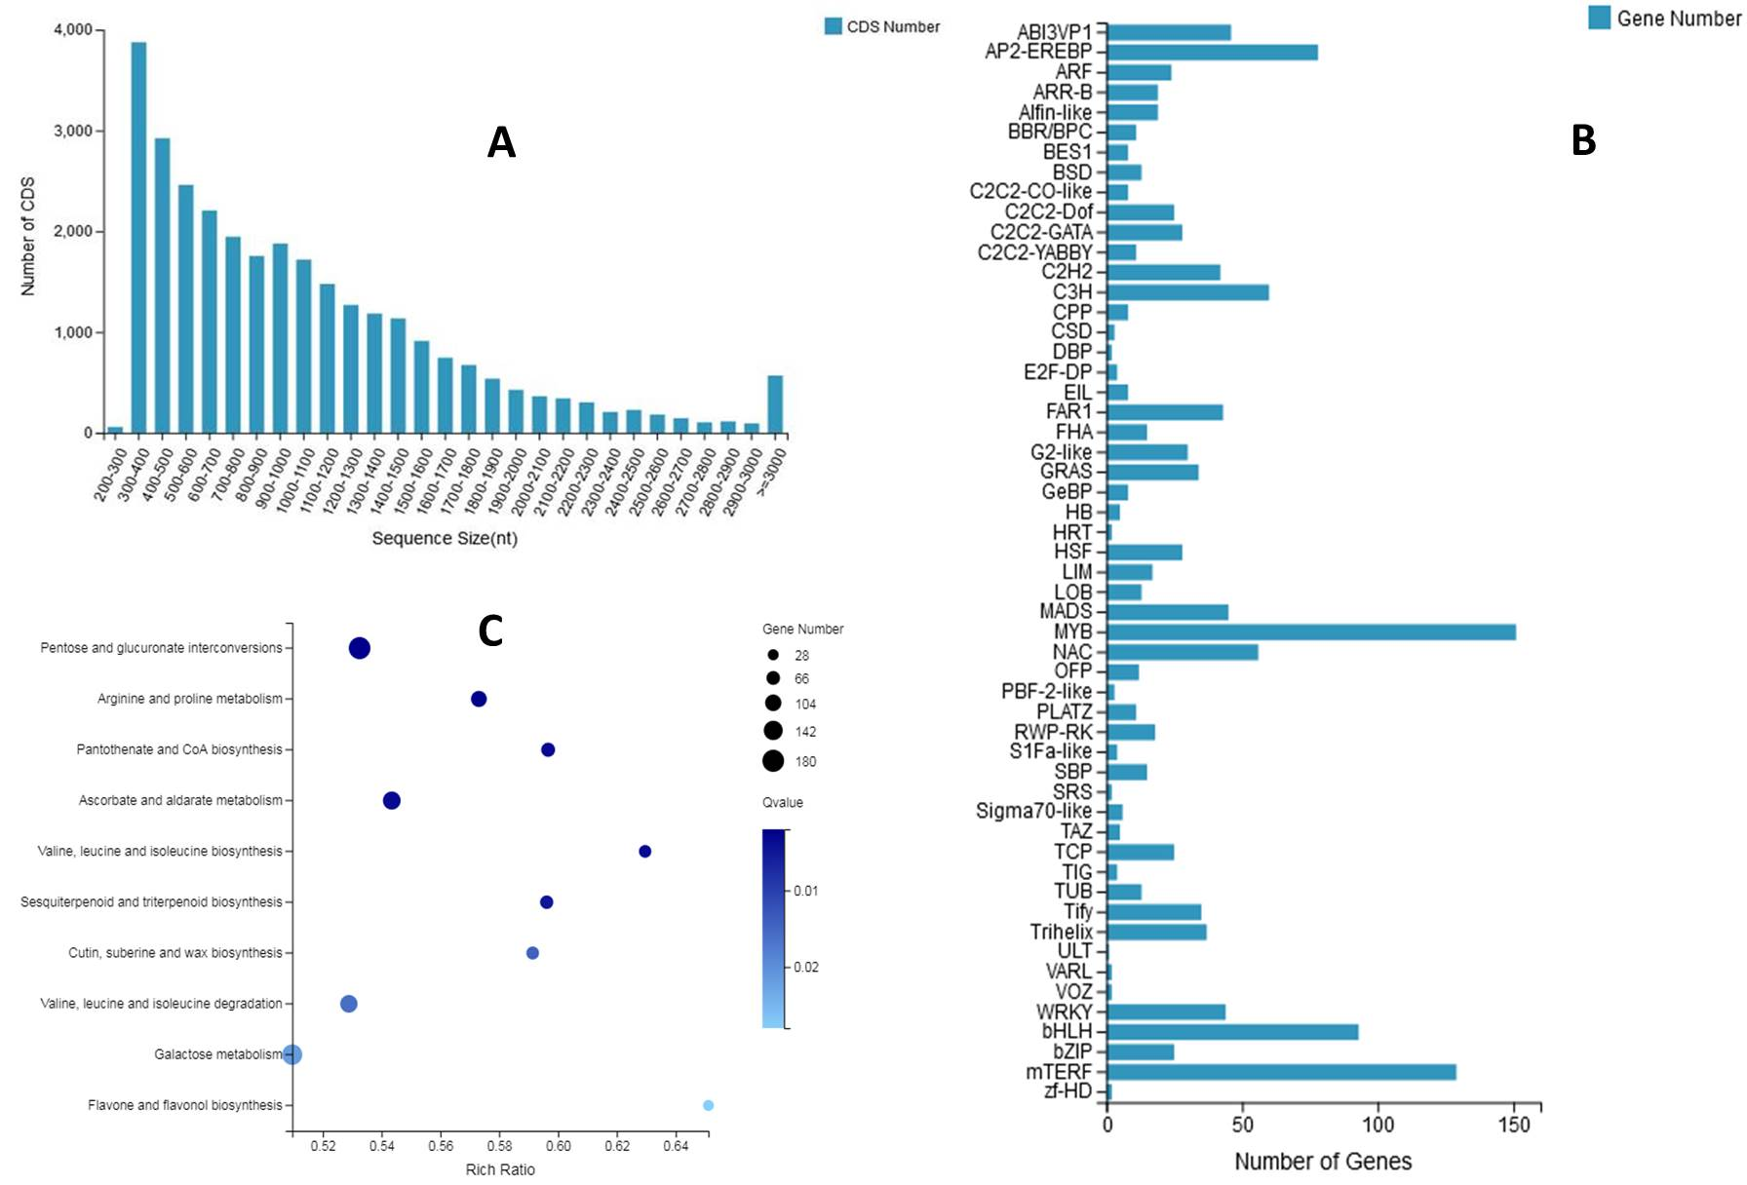
Supplementary Figure S1. A Length distribution of predicted CDS from P. grandiflorus unigenes. B Transcription factors retrieved from P. grandiflorus RNA-Seq data. C KEGG pathway enrichment analysis for differently expressed genes from PgB and PgW. Rich ratio indicated number of DEG in a certain pathway versus number of genes annotated to the same pathway.

